1. When schedule a product haul and there is a bin assigned to job already. Bin is not showing in the “Load to Bin” list.——BUG077 Fixed 1211

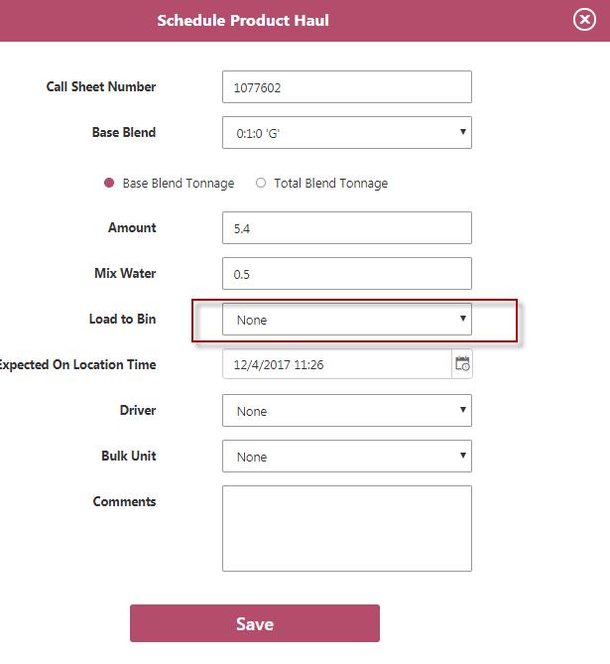

1. In Schedule Product Haul form, Driver list should be sorted by last name in this case. Basically it should be sorted by the final display string in alphabetical order. That’s will be easy if we change the name format to maintain the list being sorted correctly.——BUG078 Fixed 1205

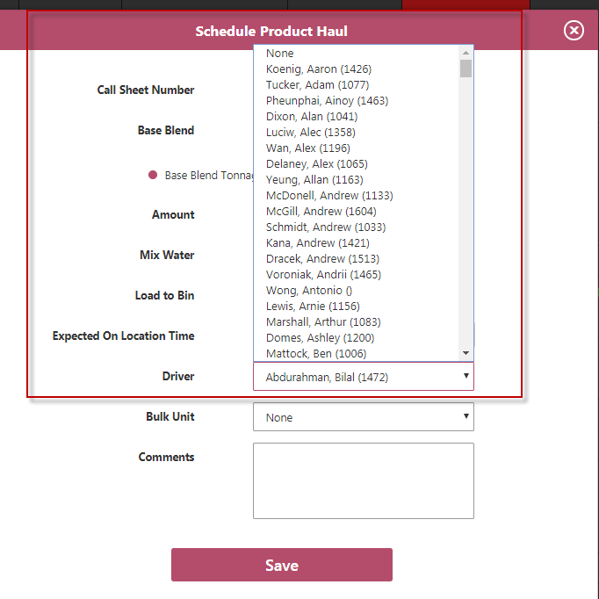

1. Under Product Hauls menu tab. Then product haul page forms need to be updated as some fields as it on Rig Board.——BUG079未修改
2. When there are product haul(s) scheduled on a blend, there are two issues.
   1. When mouse points to the red arrow, the next level menu pops up to show the product information, it should show better description. Here is an example.——BUG080 Fixed 1205

“0:1:0 ‘G’ - 5.4t – Adam Wang – 201915”

* 1. For “Re-schedule Product Haul” should be able to reschedule all product hauls, just like “Cancel”. That means there should be a red arrow to lead to next level menu.——BUG081 Fixed 1205

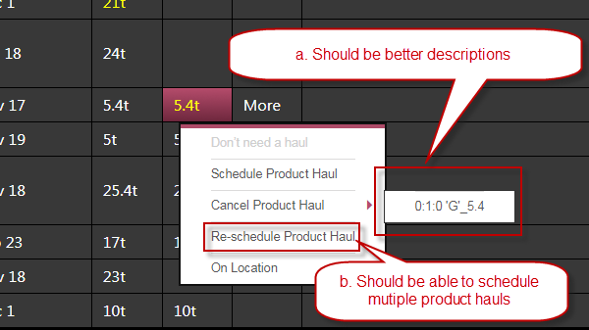

1. Missing functionality – Add product haul information in Unit/Personnel section. ——BUG083 Fixed 1205

When create a product haul, on record needs to be insert in Unit/Personnel section. When the product haul is updated, Unit/Personnel information needs to updated. When the product haul is cancelled, Unit/Personnel needs to be updated.